Log in to <https://oklahoma.measuredprogress.org/>

Select **Reporting**

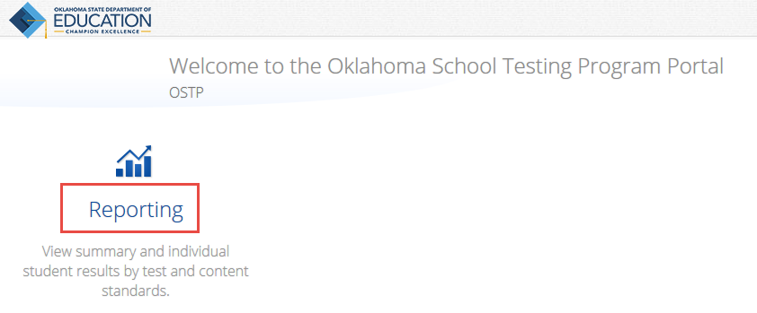

1. For Program select **OSTP**
2. For Report select **Roster**
3. Select the **Admin, Grade,** and **Release** values (you need to run this report for each grade you want to export).
4. For Organization select your district name (otherwise you will need run the report for each school.)
5. Click on **Get Report**

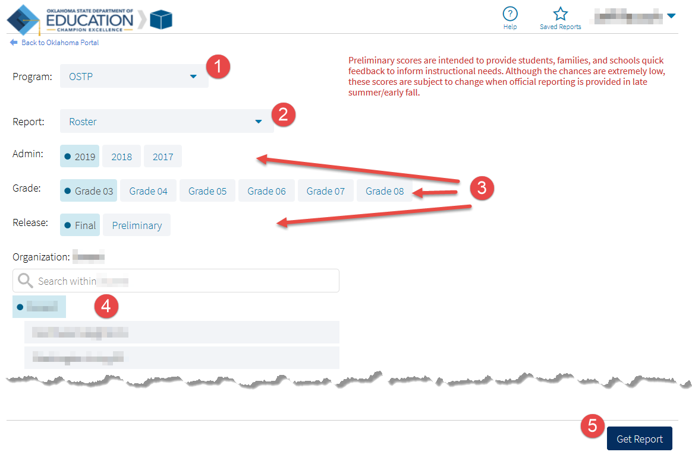

When the results are displayed, click on **Options**.

On the **Fields** tab, then click **Select All** for each section (3 total)

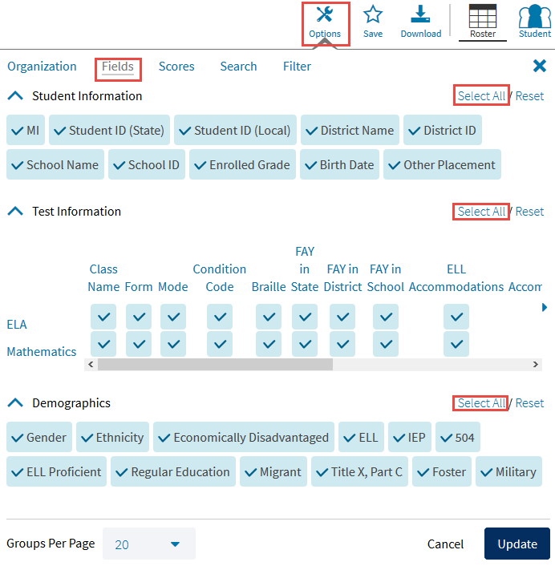

Click the **Scores** tab, then click **Select All** for each section (3 or 4 total depending on the Grade you selected)

Then click **Update**

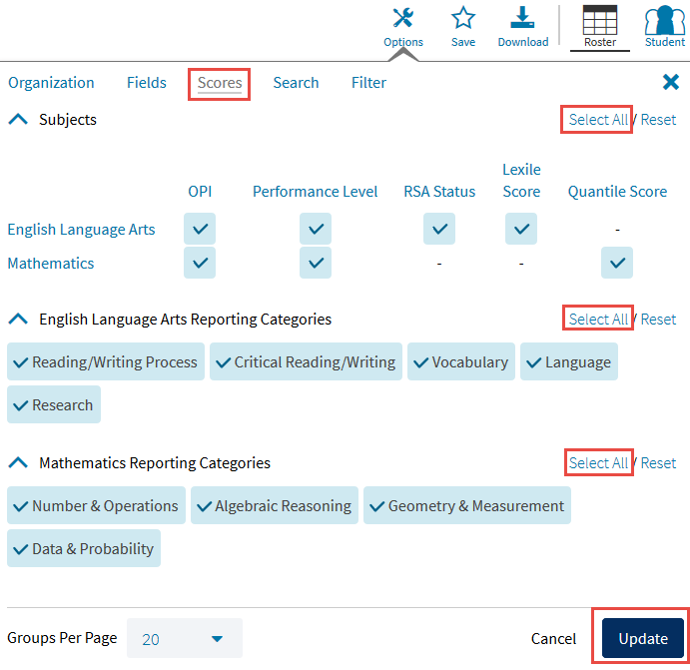

Click on Download

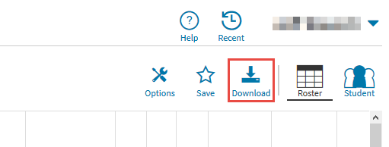

Click on CSV, change the Report Name to something descriptive, and press Download.

